Place 1: San francisco

Background image: <https://www.google.com/search?q=golden+gate+images&espv=2&biw=1920&bih=937&tbm=isch&imgil=sjxIDH8Bi6wPnM%253A%253BOKxCFaRPmvVFAM%253Bhttp%25253A%25252F%25252Fwww.howardmodels.com%25252Ffun-stuff%25252Fgolden-gate-bridge%25252FGolden-Gate-Bridge2.html&source=iu&pf=m&fir=sjxIDH8Bi6wPnM%253A%252COKxCFaRPmvVFAM%252C_&usg=__1wa7uEu_rw-aHj9CiRaKVKJsmyQ%3D>

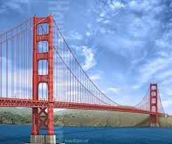

Hints:

* Hint 1: It is said that this city gave birth to the famous and scrumptious hot chocolate fudge.
* Hint 2: The bridge connecting this city with another city is the second-longest main span in the United States
* Hint 3: You can go through the most crookedest street of the world in this city
* Hint 4:Memories of the TV show Full House
* Hint 5: Image Japanese Tea Garden :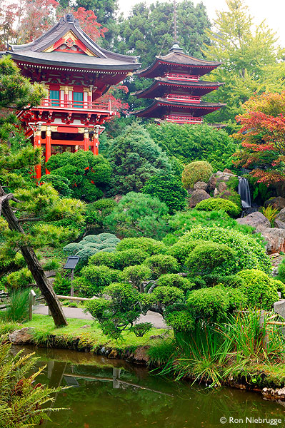
* Hint 6: audio clip:full house tv show: <http://www.televisiontunes.com/Full_House.html>

Images with their links:

* <http://www.wildnatureimages.com/California/San-Francisco/Coit-Tower-Photos.htm>(right Image)

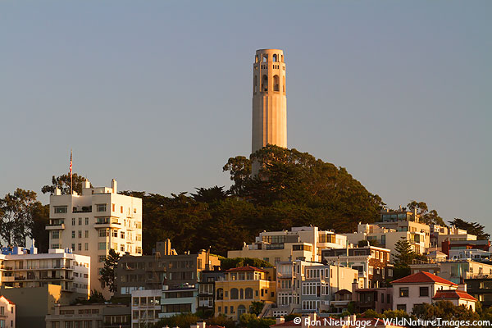

* <http://hipsploitation.com/?p=941>(wrong image)

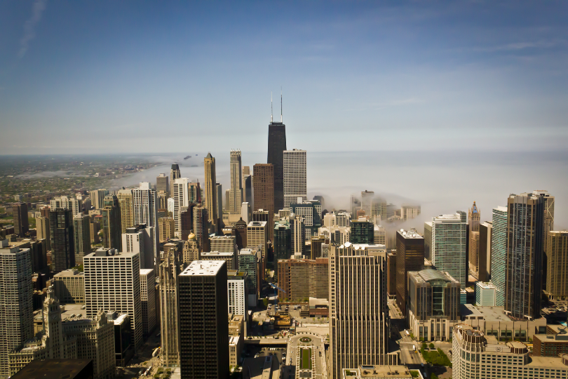

* <https://in.pinterest.com/pin/317785317432979091/> (wrong image)

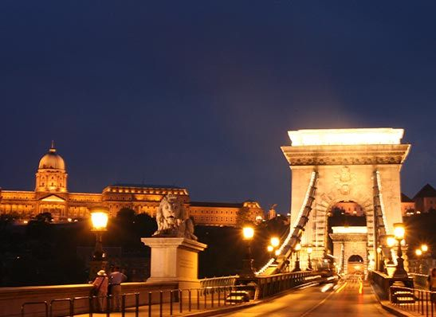

* <http://rideshareapps.com/denver-uber-promo-code/> (wrong image)

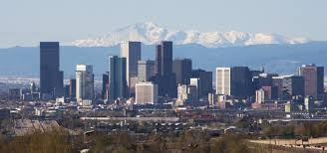

Place 2: Cape Town

Background image:

<http://www.travelstart.co.za/blog/wp-content/uploads/2013/11/Kristina-Signal-Hill.jpg>

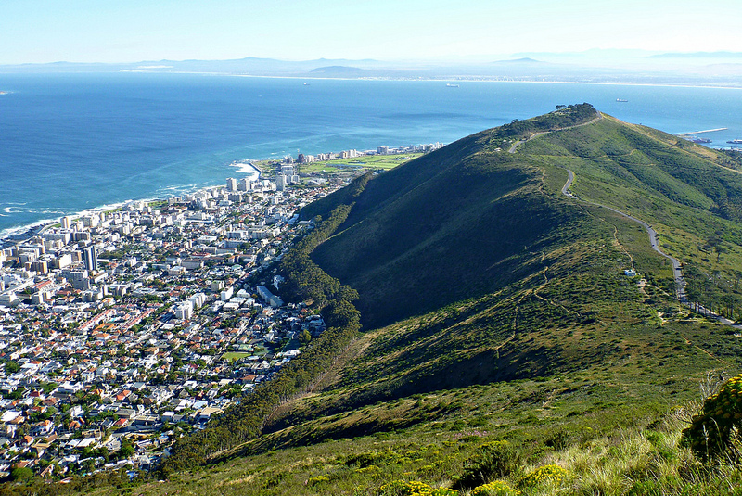

Hints:

* Hint 1:To win there is a cape of good hope
* Hint 2: Is it a table or a mountain
* Hint 3: To see the statues of noblemen visit the nobel square.
* Hint 4: Even the castle says there is good hope.
* Image hint:Boulder Island-penguins 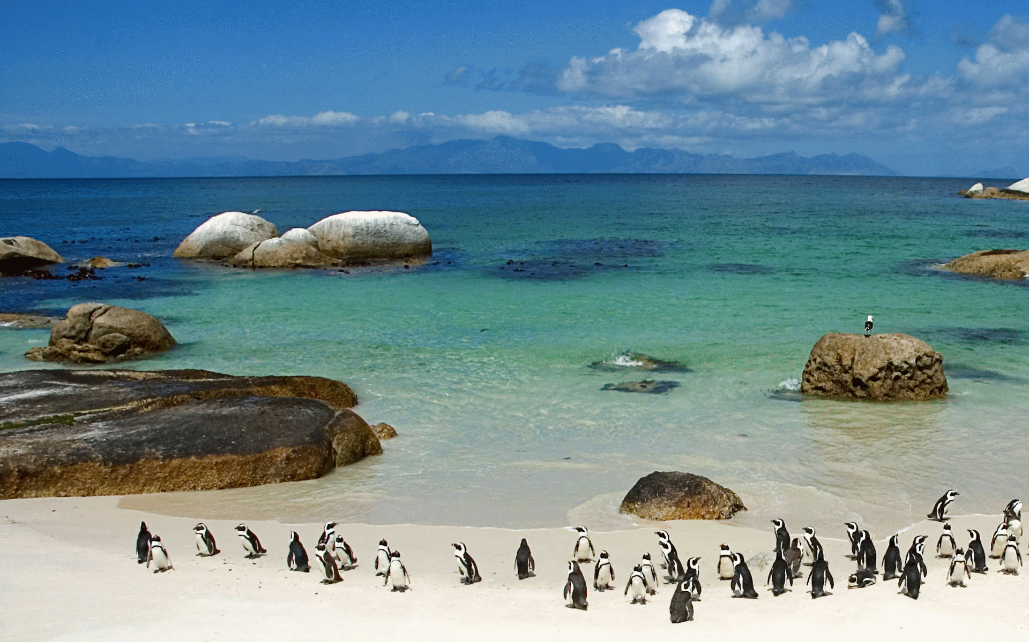
* Hint 6:title song:movie chronicle:shot in cape town: <https://www.youtube.com/watch?v=2Oz-pxRITQo>

Images with their links:

* <http://www.classicencounters.com/tablemountain.htm>(right image)

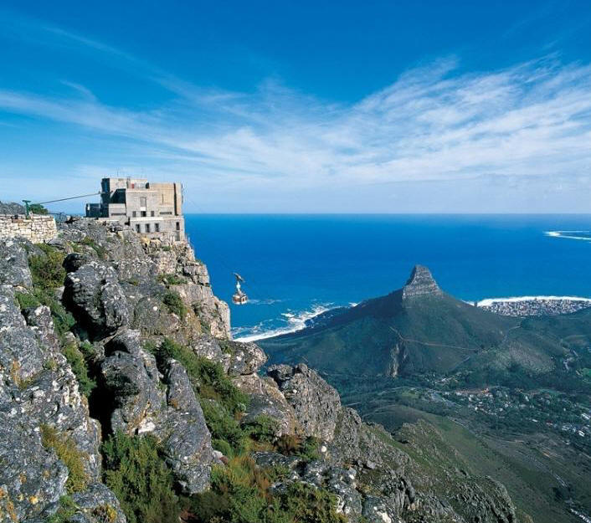

* <http://www.designyourway.net/blog/inspiration/beautiful-photography-of-cities-from-around-the-world/> (wrong image)

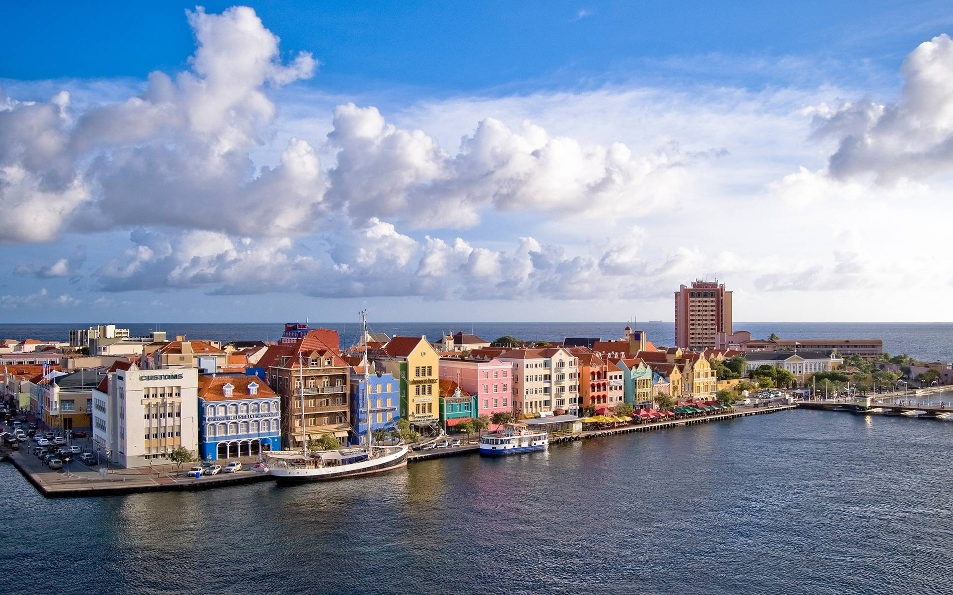

* <http://www.designyourway.net/blog/inspiration/beautiful-photography-of-cities-from-around-the-world/> (wrong image)

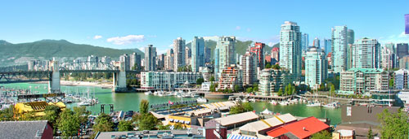

* <http://www.designyourway.net/blog/inspiration/beautiful-photography-of-cities-from-around-the-world/> (wrong image)

